# Elizabeth Taylor BAN 502 Predictive Analytics

library(tidyverse) # read in the packages I need  
library(tidymodels)  
library(GGally) #ggcorr and ggpairs  
library(ggcorrplot) #correlation plot alternative  
library(gridExtra) #create grids of plots  
library(esquisse)

library(readr) #read in the data  
ames_student <- read_csv("ames_student.csv")

str(ames_student) #review the data

#esquisser(ames_student) Helped me visualize which variables might be strong predictors of Above Average

ames = ames_student%>%dplyr::select(Above_Median,Year_Built,Gr_Liv_Area, Lot_Area, Full_Bath,Half_Bath, TotRms_AbvGrd, Year_Built,Year_Sold, Three_season_porch,Screen_Porch )  
#These were the variables that I found that seemed to be good predictions of the variable Above_Median

ames = ames %>% mutate(Above_Median = as_factor(Above_Median))   
   
ames$TotBath <- ames$Full_Bath+ ames$Half_Bath  
ames$Porch <- ames$Three_season_porch+ames$Screen_Porch  
ames <- ames %>% select(-Full_Bath,-Half_Bath,-Three_season_porch,-Screen_Porch)  
#I decide to add both half bath and full bath together to create total bath as one variable.   
#I decided that a three season porch and screen porch were similar enough to add them together as one variable  
#Once I created the new variables I subtracted the old variables out of the data set.

#ggpairs(ames) #So I can visualize my variables on my secdata set

ggplot(ames) +  
 aes(x = TotBath, y = Above_Median) +  
 geom_boxplot(fill = "#112446") +  
 labs(  
 x = "Total number of Bathrooms",  
 y = "Sold Above Median Price",  
 title = "Total Bath"  
 ) +  
 theme_minimal()

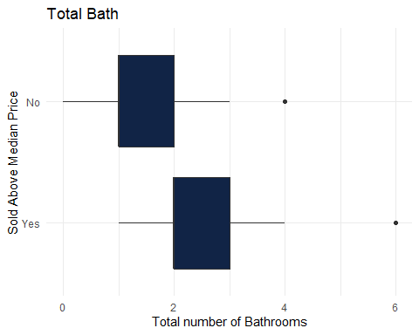

ggplot(ames) +  
 aes(x = Year_Built, y = Above_Median) +  
 geom_boxplot(fill = "#112446") +  
 labs(  
 x = "Year Built",  
 y = "Sold Above Median Price ",  
 title = "Year Built"  
 ) +  
 theme_minimal()

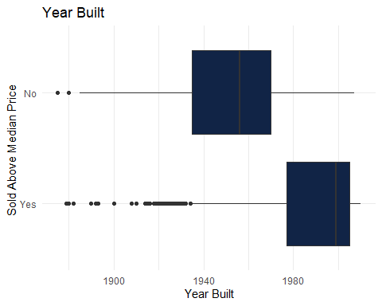

ggplot(ames) +  
 aes(x = Above_Median, y = Lot_Area) +  
 geom_boxplot(fill = "#112446") +  
 labs(  
 x = "Size of Lot",  
 y = "Sold Above Median Price",  
 title = "Size of Lot"  
 ) +  
 theme_minimal()

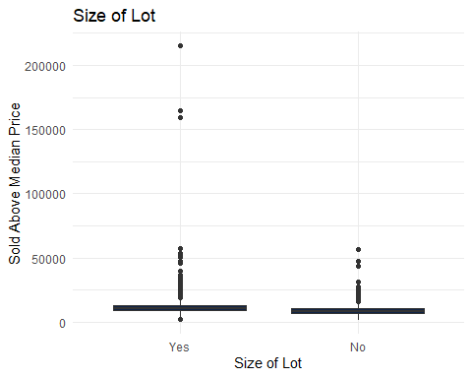

ggplot(ames) +  
 aes(x = TotRms_AbvGrd, y = Above_Median) +  
 geom_boxplot(fill = "#112446") +  
 labs(  
 x = "Total Rooms",  
 y = "Sold Above Median Price ",  
 title = "Total Rooms"  
 ) +  
 theme_minimal()

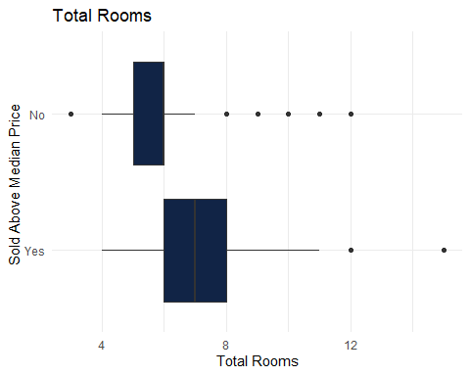

ggplot(ames) +aes(x = Porch, y = Above_Median) +  
 geom_col(fill = "#112446") +  
 labs(  
 x = "Porch",  
 y = "Sold Above Median Price ",  
 title = "Porch or 3 Season Room"  
 ) +  
 theme_minimal()

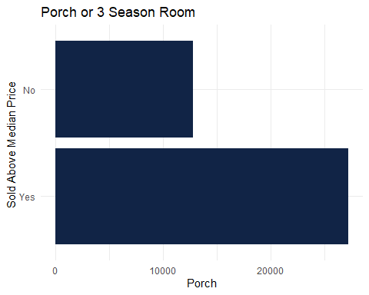

theme_minimal()  
ggplot(ames) +  
 aes(x = Above_Median, y = Gr_Liv_Area, ) +  
 geom_col(fill = "#112446") +  
 labs(  
 x = "Total Sq Footage",  
 y = "Sold Above Median Price ",  
 title = "Size of House"  
 ) +  
 theme_minimal()

